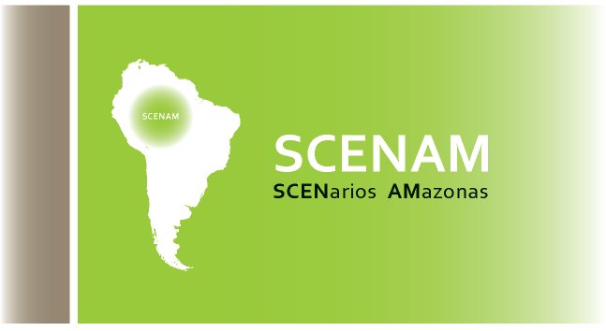

SCENARIOS AMAZONAS-The pyramid of Interests

Local Ownership

The buy-in of the local actors in any natural resources management intervention is fundamental for its effectiveness because their decision as far as resources use is concerned directly influence ecosystems functioning and resilience. For this reason, the engagement of local stakeholders should happen in a direct manner, from the outset of the intervention (if possible, prior to its actual design) so that those actors can be involved in the whole of the process of management of their resources and thus own that management.

The Pyramid of Interests

The Amazon region is immense in all of its dimensions – geographic, social, economic, political, ethnic, and cultural. The pyramid represents the diversity of interests, desires and needs of the local actors (individuals and institutions) living the Amazonian reality. A scenarios exercise (or series of exercises) for the Amazon region to support the design of a transboundary basin-wide water resources management (WRM) plan only makes sense if that diversity is represented in its full.

The participation of local actors should not be summarized to a round of interviews or focal groups exercises. Their participation should be active and, should happen throughout the process of design and implementation of the WRM plan. However, the interviews should constitute a starting point of the scenarios exercise as a way of making a first selection of the common elements of concern, present among the diversity of local actors throughout the Basin.

In the Amazon Basin each indigenous group faces different challenges, a different past, and also different legal and institutional frameworks. But in each country, we have a rich array of stakeholder groups. In a Basin-wide initiative, the process has to capture the different challenges, aspirations and needs to the highest extent that is feasible, and will have to find a criterion to elect which ones are “stronger” and that are fundamental to assess what is going on at the Basin level.

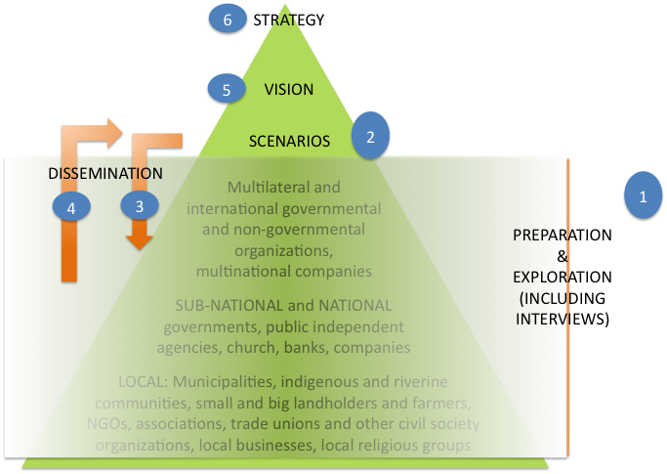

The election of those “stronger” elements should happen before standards that are Amazonian. For this reason, the scenarios exercise will happen as a process that cycles back to the majority of local actors. After being initially consulted through interviews during the preparation and exploration phase, the scenarios (or storylines) developed based on the information provided by the local actors and elaborated by a group of people that includes their representatives will be shared with them. They will learn those storylines. Then, they will have the opportunity of criticizing and adding to those storylines, too. That information will feed the review of the scenarios and will allow the definition of a vision for the water resources of the Basin and of a strategy towards that vision. This constitutes the dissemination phase of the scenarios process.

Reaching out and Political Support

The ability of the GEF Amazonas team of reaching out to the Basin as a whole is contingent upon a communication strategy that is quite complex and that will certainly require the bulk of the scenarios exercise resources. On the other hand, the fact that all GEF projects are country owned and supported means that the project GEF Amazonas has the political support at the country and region levels to reach all parts of the Amazonian social fabric.

An extended vision for SCENAM

SCENAM has the mission of not only supporting scenarios exercise that should serve as the basis for the SAP of the GEF Amazonas project, but of the series of exercises that should be run at the more local level and upon which local WRM plans and well as management plans for other natural resources and local development may be elaborated.

However, it must be made clear that the local communities are not the only ones with stakes in the regions, i.e. they are not the only ones that depend on that reality and that can influence it, even though they are fundamental to the effective implemention any of environmental project.

